**Adama Science and Technology University**

**School of Engineering and Information Technologies**

**Department of Electrical and Computer Engineering**

**Exam Date: Apr 2, 2013 Time allotted: 3 hrs**

**Total Marks: 20%**

***Instruction***

1. *Read carefully and work out the questions according to their order on the exam sheet.*
2. *State your assumption if any is used.*
3. *Clear and neat answer is worthy.*

**EEng 3203: Applied Electronics I Mid exam**

1. *Do not use pencil and red pen.*

**PART I: ANSWER THE FOLLOWING QUESTIONS BRIEFLY AND PRECISELY TO THE POINT**

Q 3 Compare the energy band model of silcon with that of germanium.(2)

Q 1 Briefly explain the difference between intrinsic and extrinsic semiconductor materials.(2)

Q 2 What is the effect of doping on the resistance of the semiconductor? (1)

Q4 . Discuss the effect of biasing on the width of the depletion region at a p-n junction.**(2 pts.)**

Q5 Discuss the operation of a power supply system wit block diagram by showing the corresponding out put waveform from each block. **(3 pts.)**

**PART II WORK OUT THE FOLLOWING QUESTIONS BY SHOWING YOUR STEPS CLEARLY.**

Q1.

(a) Determine VL, IL, IZ, and IR for the network Fig. below if RL =120Ω (2)

(b) Repeat part (a) if RL = 500Ω. (2)

(c) Determine the value of RL that will establish maximum power conditions for the Zener diode.(1)

(d) Determine the minimum value of RL to ensure that the Zener diode is in the “on” state (1)



Q2. Sketch V*o*for the network of Fig. 2 and determine the dc voltage available. **(2 pts.)**



**Fig 2**

Q3. The secondary voltage has a maximum value of 30 V with 50 Hz and RL= 400 Ω as shown in fig 3,

a) What is the dc output voltage & dc current? **(2 pt)**

b) Draw the output wave shape characteristics of Vo, VD1, , VD3, (1)

(c) Find the maximum current through each diode during conduction (1)

d) If a filter capacitor of C= 220 μf is connected in parallel to the load, of RL = 400Ω, calculate the dc output voltage and dc current?  **(2pts.)**

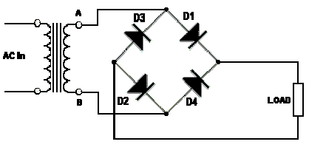

**Fig -3**

Q4. Name the circuit and draw the out put waveform for the circuit shown in fig 5 on the space provided with a brief explanation. (assume ideal diode) **(1pts.)**

